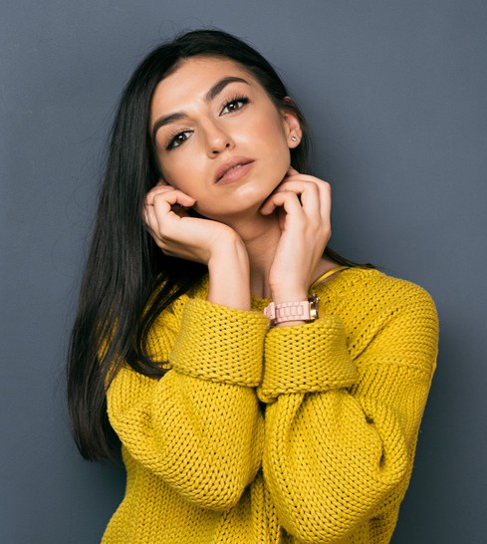Brigitte

Schwartz
Hello I am a pro photographer. I have a lot of experience in
the field of photography and photo editing

Educations
Borcelle University 2014 - 2018
Fauget University 2011 - 2014
Fauget University 2011 - 2014

Experience
Illustrator
Paucek and Lage Studio 2020 - 2021
Senior Illustrator Studio Shodwe 2021 - present

Skill
Character Design Motion Character Public Speaking

Contact Me
+123-456-7890
hello@reallygreatsite.com
123 Anywhere St., Any City, ST 12345

Interests


